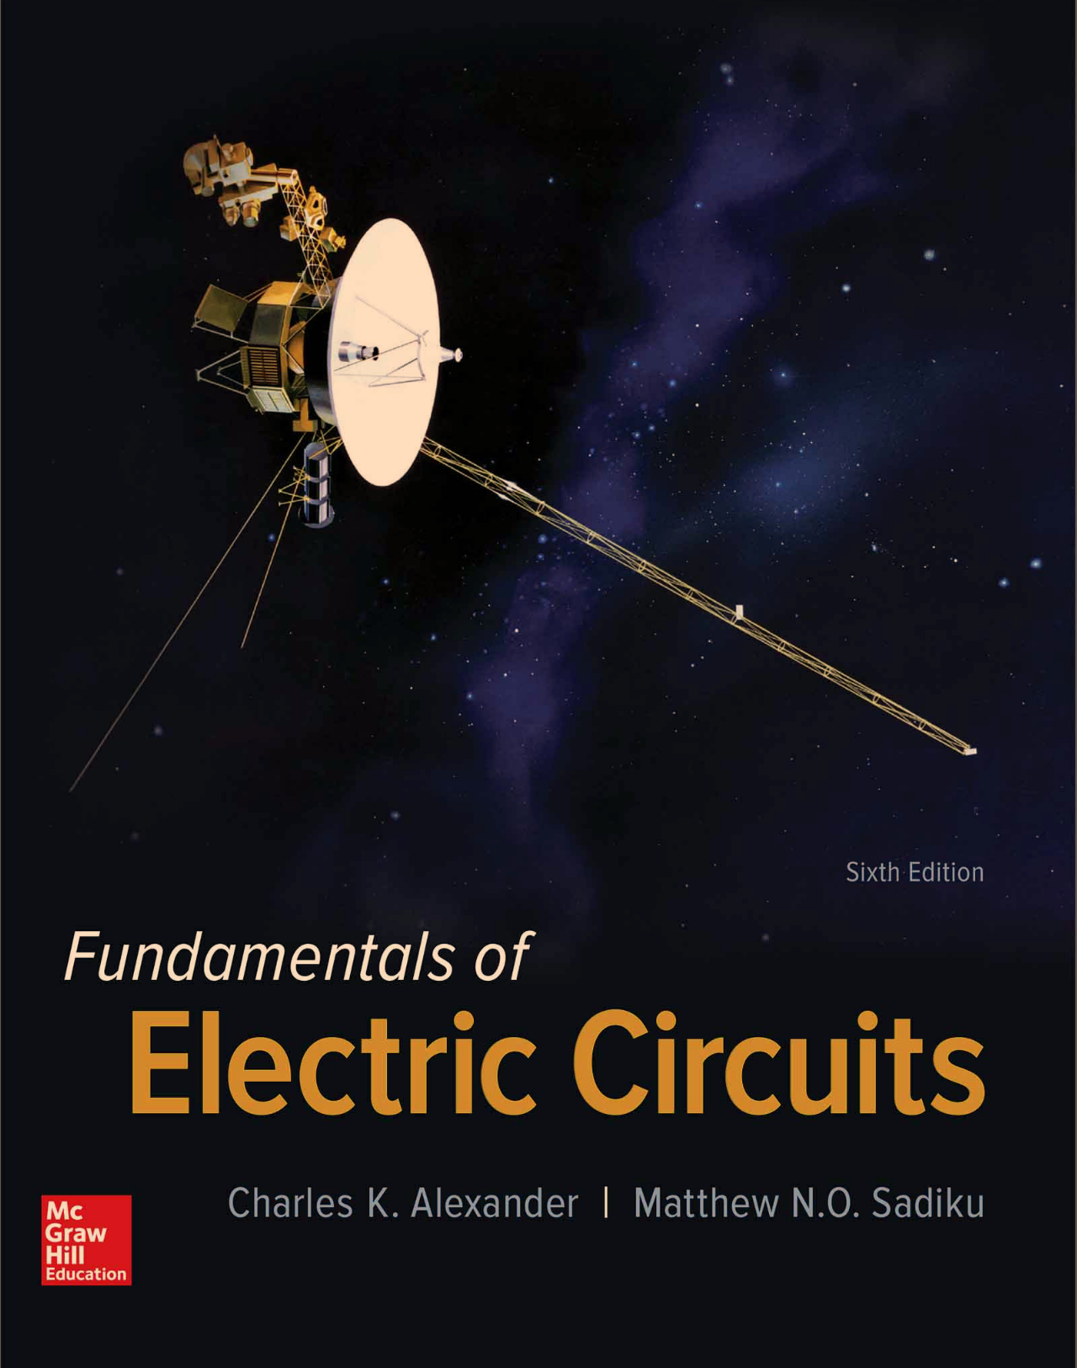

1. Please solve and write the answer to all of the given **Practice Problem 8.7, 8.9, 8.10, 12.4, and 12.5** in handwriting. And take a picture for the solutions and attach the picture to the assignment file.